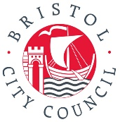
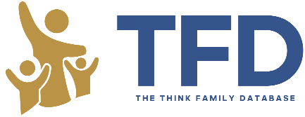
Think Family Education
Service User Charter

This charter outlines commitments to standards of best practice that Think Family Education (TFE) users must take due to the personal sensitive data that is being shared. Ensuring fair and proper use of data about young people is not only paramount to the young person’s wellbeing but also to comply with relevant Data Protection legislation, such as the Data Protection Act 2018, Computer Misuse Act 1990 and the UK GDPR. Good practice in data protection is vital to ensure public trust in, engagement with, and support for, innovative uses of data.
Responsible Authority | Educational Setting | Date
As a school we are committed to:
- Using TFE to make professional decisions in the best interest of the child.

- Limiting staff access to those with pastoral or safeguarding roles that have the training and experience to handle highly sensitive safeguarding data eg Safeguarding level 3 or at DSL level.

- Using TFE data confidentially within the setting and with staff who have been identified with adequate training and experience. Sharing of any data is in accordance with the setting internal policies and shared on a limited need to know basis.

- Not using the TFE for personal use. Ascertain data about personal connections and sharing data with other settings is strictly prohibited.

- Compliance with Information Governance as stated within the Information Sharing Agreement (ISA) and Data Protection Impact Assessment (DPIA)
As a school we understand:
- TFE is updated daily but between one update and the next there may be changes we cannot yet see.

- TFE is designed to be used to complement the educational settings data and other initiatives such as the Police’s safeguarding notification process.

- TFE cannot provide a complete picture of a student's life experience or the context for incidents and indicators.

- TFE data cannot provide justification for behaviour sanctions, including exclusions.

- Use of TFE will be monitored and audited.

- The responsible authority will carry out random spot checks to ensure compliance with charter and legal responsibilities.

- Staff should be advised to seek managerial advice regarding searching pupils known to them other than through their work at the school

