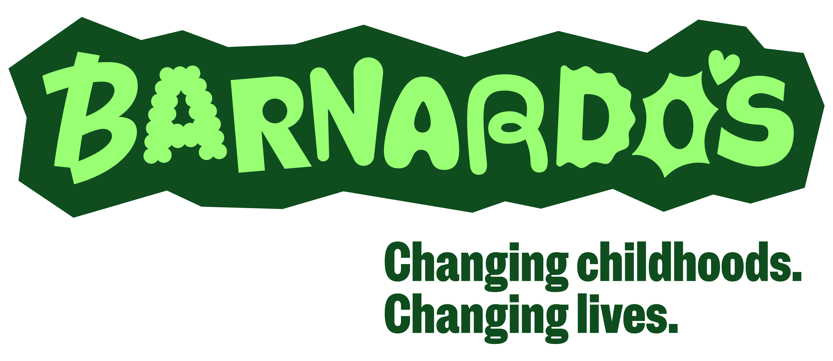

38-39 Old Market Service
Old Market
Bristol
BS2 0EZ

Tel 0117 9349726
Email Oldmarketservices@barnardos.org.uk
Web www.barnardos.org.uk

Dear School

I’m writing to confirm that Barnardo’s staff, who will always have their Barnardo’s ID badge on them, have all been subject to an Enhanced DBS at the start of their employment with us and on a 3 yearly cycle thereafter.

As a leading and largest children’s charity within the UK, we recognise the importance of upholding high safeguarding standards and therefore undertaking rigorous checks of our staff.

To provide extra reassurance, Barnardo’s is named on The Safeguarding In Education website- Letters of assurance for visiting professionals Bristol

In addition to this we work hard to ensure we adhere to the Keeping Children Safe in Education (2024) guidance which would define us as a professional visitor and states:

308. For visitors who are there in a professional capacity schools and colleges should check ID and be assured that the visitor has had the appropriate DBS check (or the visitor’s employers have confirmed that their staff have appropriate checks. Schools and colleges should not ask to see the certificate in these circumstances).

All staff within Barnardo’s have therefore been advised that this letter and their ID badge should be sufficient and they are not required to show or provide a copy of their DBS, which is a personal document between staff and employee.

Please accept this letter as confirmation that Barnardo’s staff – as evidenced by them carrying an in-date Barnardo’s ID badge – do have a current Enhanced DBS.

Any queries please contact Barnardo’s Old Market Services on the contact details above and ask to speak to the Children’s Service Manager.

Yours sincerely
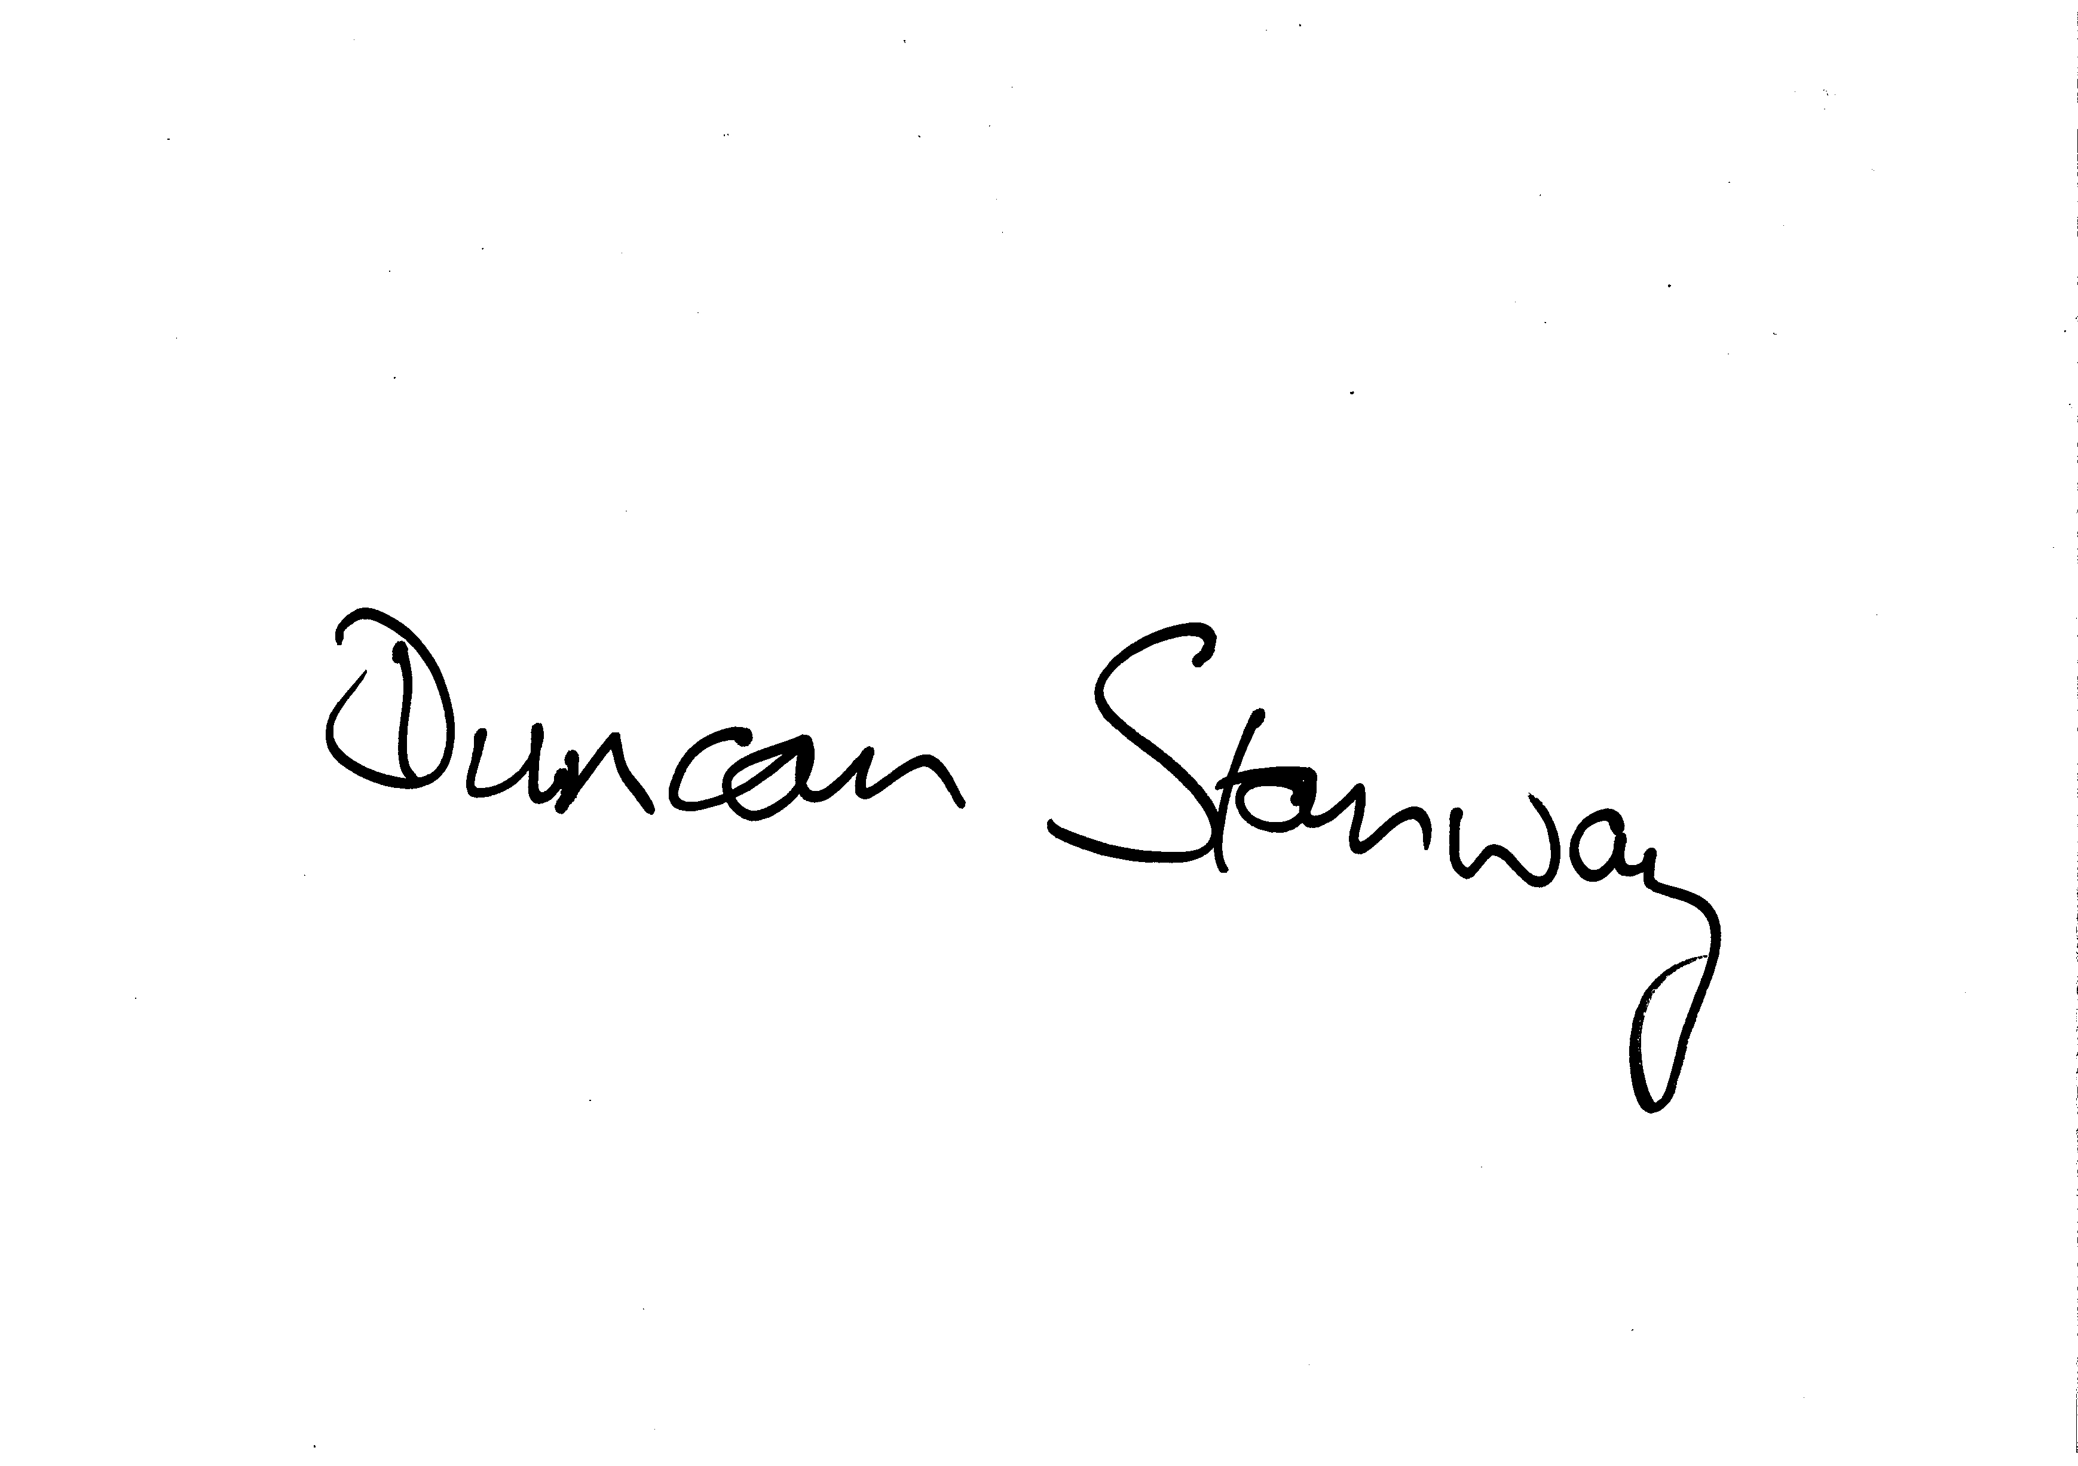
Duncan Stanway
Assistant Director Children’s Services

